**Analyzing the Redshift**

**Introduction/Background**

In 1929 Edwin Hubble announced that almost all galaxies appear to be moving away from us. In fact, he found that the universe was expanding - the galaxies are moving away from each other. This phenomenon is observed as a ***redshift*** in a galaxy's spectrum. This redshift is larger for faint (farther away) galaxies. In this activity you will analyze the data from seven galaxies and determine the relationship between the distance of a galaxy from Earth, the velocity of the galaxies, and their redshift.

**Phenomena/Observations to be Explained**

The wavelengths of light emitted from galaxies vary based on the distance of the light from the galaxy.

**Essential Questions/Focus Questions**

What *patterns* do we observe when comparing the wavelength of light emitted to the speed and distance of a galaxy from from Earth?

**Part A:** The table below shows red-shift data from distant galaxies. Distances are given from Earth in mega parsecs (Mpc), where one parsec is equal to 3x1016m (30,000,000,000,000,000 m). The redshift data is given as a percentage increase in the original wavelength. (Note - Megaparsec = 1,000,000 parsecs)

**Data**

| **Galaxy** | **Distance from Earth (Mpc)** | **Increase in wavelength (% increase on original wavelength)** |
| --- | --- | --- |
| NGC-5357 | 0.45 | 0.07 |
| NGC-3627 | 0.9 | 0.22 |
| NGC-5236 | 0.9 | 0.17 |
| NGC-4151 | 1.7 | 0.32 |
| NGC-4472 | 2.0 | 0.28 |
| NGC-4486 | 1.8 | 0.27 |
| NGC-4649 | 2.4 | 0.36 |

**Using the table above, answer the questions below:**

1. What galaxy shows the largest increase in wavelength? <the galaxy with the largest increase would be NGC-4649.>

2. What is the distance from earth of the galaxy that shows a redshift of 0.32%?<the distance is 1.7 Mpc

3. What is the difference in distance (in Mpc) between NGC-5236 and NGC-4151? <The difference of distance is 0.8Mpc

4. What Claim can you make about the relationship between the distance of a galaxy

from Earth and the redshift observed? <as the distance of a galaxy increases the Wavelength/ increase of redshift also increases(goes faster)>

5. Which of these variables , distance or % redshift, would be the dependent variable? Explain.

<the D.V. is the distance from the earth because it does not change and to find different data you can keep the distance the same, Also for each galaxy you can not change the distance. >

6. Using the axis below, plot a graph of the distance of a galaxy from earth against the percentage of red-shift observed:

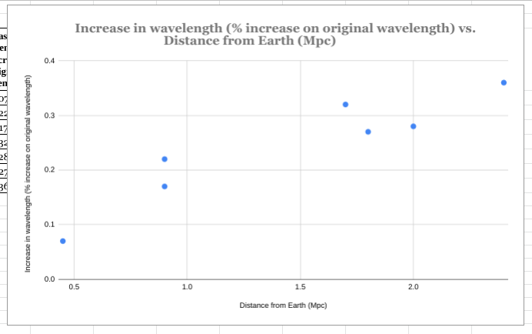

**Part B:**  The speed that a galaxy is moving at can be found by multiplying the percentage increase in wavelength by the speed of light (300,000,000 meters/second) and then dividing by one hundred (because it’s a percent). Fill in the table below with the speed of the galaxies and show your work. Make sure you include the proper units.

**Sample Galaxy:** If a galaxy’s distance from Earth is 2.5 Mpc and an increase in wavelength measures 0.39%, calculate the speed of the galaxy in meters/second and in km/second.

| **Galaxy** | **Calculations**  **(% increase in wavelength x speed of light/100)** | **Speed of Galaxy (m/s)** | **Speed of Galaxy (km/s)** |
| --- | --- | --- | --- |
| **Sample Galaxy** | .39 x 3.0 x 108 m/s x 1/100 | 1.17 x 10 6 m/s | 1.17 x 106 m/s x km/1000m=  1.17 x 103 km/s |
| NGC-5357 | 0.07 x 3.0 x 108 m/s x 1/100 | 2.1 x 10 5 m/s | 2.1 x 10 5 m/s x km/1000m=  2.1 x 102 km/s |
| NGC-3627 | 0.22 x 3.0 x 108 m/s x 1/100 | 6.6 x 10 5 m/s | 6.6 x 10 5 m/s x km/1000m=  6.6 x 10 2 km/s |
| NGC-5236 | 0.17 x 3.0 x 108 m/s x 1/100 | 5.1 x 10 5 m/s | 5.1 x 10 5 m/s x km/1000m=  5.1 x 102 km/s |
| NGC-4151 | 0.32 x 3.0 x 108 m/s x 1/100 | 9.6 x 10 5 m/s | 9.6 x 10 5 m/s x km/1000m=  9.6 x 10 2 km/s |
| NGC-4472 | 0.28 x 3.0 x 108 m/s x 1/100 | 8.4 x 10 5 m/s | 8.4 x 10 5 m/s x km/1000m=  8.4 x 10 2 km/s |
| NGC-4486 | 0.27 x 3.0 x 108 m/s x 1/100 | 8.1 x 10 5 m/s | 8.1 x 10 5 m/s x km/1000m=  8.1 x 10 5 km/s |
| NGC-4649 | 0.36 x 3.0 x 108 m/s x 1/100 | 1.08 x 10 6 m/s | 1.08 x 10 6 m/s x km/1000m= 1.08 x 10 3 km/s |

1. Create a graph that presents the distance to each galaxy in mpc on the horizontal axis, and the speed in kilometers/sec on the vertical axis.

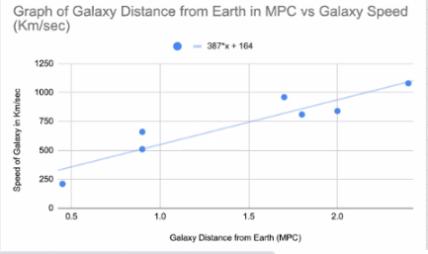

1. What is the range of distances to the galaxies in this sample in light years? < The range is from 0.45-2 Mpc. Since 1 Mpc= 3.26 light years, the range is 450,000 pc x 3.26 light years/pc = 1,467,000 light years to 2,000,000 pc x 3.26 light years/pc = 6,520,000 light years.
2. Does the data show that the distances and speeds of the galaxies are correlated, anti-correlated or uncorrelated (random)? <the data shows a correlated relationship between these, because the data points show an increasing speed with increasing distance.>
3. By using a calculator, or using an Excel Spreadsheet, plot the data and use the 'Tools' to determine a best-fit linear regression. Alternatively, you may use the graph you created in Problem 1 to draw a best-fit line through the data points.

-The same graph works

1. The slope of the line in this plot is called **Hubble's Constant**. What is your estimate for Hubble's Constant from the data you used? Your units are kilometers/second per megaparsec.

My estimate would be a slope around 400 Km/Sec

1. An astronomer measures the speed of a galaxy as 2500 kilometers/sec. What would its distance from us be using your linear regression (now called Hubble's Law)?

speed= 400 x distance(Km)+ 140 distance= 2500 Km/sec -140 / 400 = 5.9 Mpc

**Analysis/Conclusions**

1. What would the universe and its evidence have looked like 10 billion years ago? <insert your answer here>
2. What will the universe and its evidence look like in 5 billion years? <insert your answer here>
3. Do you need to measure spectra from *every* galaxy out there to be confident about Hubble’s Law? Why or why not? <insert your answer here>
4. How has the data and your graphs helped inform you about the evidence we use to understand the Expanding Universe? <insert your answer here>

**Teacher Section**

| DCI/Content  ESS1.A The study of stars’ light spectra and brightness is used to identify compositional elements of stars, their movements, and their distances from Earth.  PS4.A The wavelength and frequency of a wave are related to one another by the speed of travel of the wave, which depends on the type of wave and the medium through which it is passing. | SEP/Practices  Develop, revise, and/or use a model based on evidence to illustrate and/or predict the relationships between systems or between components of a system. | CCC/Concepts  Algebraic thinking is used to examine scientific data and predict the effect of a change in one variable on another (e.g., linear growth vs. exponential growth) |
| --- | --- | --- |

Part B: Hubble’s Law Answer Key

<https://drive.google.com/a/tamdistrict.org/file/d/0B8Ce_XDx7NWuRFlGbmktNWtZNUU/view?usp=sharing>

Hubble’s Law Activity-(This is NASA’s version of part B of this activity, if you want to use that):

<https://spacemath.gsfc.nasa.gov/universe/5Page1.pdf>